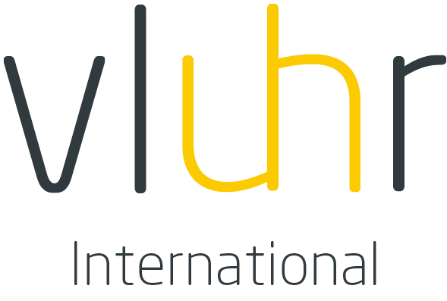

Master Mind Scholarships
Application form Academic year 2022-2023
This word version application is only for reference. Please do not submit this application by email.
Only online submission by the Flemish higher education institution is eligible.

Applicant

last name
first name(s)
date of birth (dd/mm/yy)
gender | male female
civil status | single married
nationality
e-mail address
personal email address
international passport number*
international passport
date of issue (dd/mm/yy)
international passport
place of issue
international passport
expiry date (dd/mm/yy)
current student status | bachelor master other
current/latest study field
current/latest study programme
study start date (dd/mm/yy)
expected graduation date (dd/mm/yy)
number of ECTS already awarded **

* Please submit a copy of your passport
**Please submit a transcript of records, and your acquired diploma(s) if applicable.

Language scores

type of language test taken*
date test taken (dd/mm/yy)
writing
reading
listening
speaking

* Please submit your official language test results.

Flemish host institution

Please use the links to the Flemish higher education institutions, and/or the link to the Study in Flanders search engine (http://www.studyinflanders.be/en/study-programmes/) to identify an institution and department where you would like to study.

Please provide details of the Flemish host institution you have already established contact with.

name of Flemish host institution | Luca School of Arts
department | Admissions Office
official name of the master programme you want to follow | Choose one of these programmes:  - Master of Audiovisual Arts (Genk)  - Master of Visual Arts (Genk)  - Master of Product Design (Genk)  - Master of Audiovisual Arts (Brussel)  - Master of Visual Arts (Brussels)  - Master of Visual Arts (Gent)  - Master of Music (Leuven)  - Master of Drama (Leuven)
number of credits of the master programme you want to follow | 60 ECTS (except Music: 120 ECTS)
contact person name | Mr Wim Aerts
email | international@luca-arts.be
telephone number | +32 2 250 11 00

Permanent address details
street
country
post code
city
mobile phone number

Bank details
Bank name
BIC/SWIFT
IBAN/bank account number
name of the account holder

Certification of authenticity

The undersigned states on his / her honor that the information provided in this application is correct and complete.

date of submission
signature of applicant

signature of contact person at host institution

official stamp of host institution

Authorized signature and official stamp are required after selection is made. There is no need for signature and stamp during application procedure.

The application has to be submitted to international@luca-arts.be by Monday, April 25th 2022 at the latest and has to consist of the below-described documents. LUCA will submit the application online to VLUHR-I by 29th April 2022.

Documents to submit with the application:
- Passport photo;
- International passport or national registration card;
- Transcript of records; if written in another language than Dutch, French or English, a certified translation must be enclosed.
- A Curriculum Vitae (including your American GPA out of 4.0 and if applicable your publications, academic awards, previous scholarships, etc.)
- English language test results or Letter of exemption provided by the Host university. Online language tests of IELTS and TOEFL will also be accepted:
  - IELTS Indicator (https://www.ieltsindicator.com/)
  - TOEFL iBT Special Home Edition (https://www.ets.org/s/cv/toefl/at-home/)
- Letter of motivation written in English
- Two signed letters of recommendation from professors of your (previous) Home university, University of Applied sciences, School of Arts or recent employer written in English.
- Copy of acquired diploma(s); if written in another language than Dutch, French or English, a certified translation must be enclosed.

Documents provided by LUCA at the end of the internal selection phase:
- Three reasons of motivation for submission (at least 150 words) of the candidate’s file formulated by the Host institution in English; format: entry box in the application form or a separate document.

Upon completion of the mobility, all students are expected to submit an essay for which a format is provided and to fill in a short questionnaire about their mobility.

