Instruction Manual

Registration at LUCA School of Arts as an **exchange student**

## **Step 1: Create and activate your personal account/ login**

1. New users:

* Go to <https://account.kuleuven.be/register.html?execution=e3s1>

***Note****: If the page is in Dutch, click on ‘EN’ in the upper right corner*

* Fill in your details to create an account.

***Note****: Please only use standard accents in your name*

* You will receive an email confirmation with 2 possible ways to activate your account. We recommend clicking the first link (already including your username).
* Activate your account by setting up a password and make sure your password meets the requirements.

1. Users who already have an association KU Leuven account:

* Log in at <https://account.kuleuven.be/login.html> and go to Step 2

## **Step 2: Click the link below to access the application tool**

|  |
| --- |
| **English version LUCA** |
| Link: [https://webwsp.aps.kuleuven.be/sap/bc/ui5_ui5/sap/zc_ad_appl/index.html?instelling=51181994&sap-language=en&sap-syscmd=nocookie&sap-client=200 &saml2idp=https%3a%2f%2fidp.kuleuven.be%2fidpx](https://webwsp.aps.kuleuven.be/sap/bc/ui5_ui5/sap/zc_ad_appl/index.html?instelling=51181994&sap-language=en&sap-syscmd=nocookie&sap-client=200%20&saml2idp=https%3a%2f%2fidp.kuleuven.be%2fidpx) |

## **Step 3: Upload your profile picture**

🡪 In the upper left corner you can upload your profile picture. If your application is approved, this picture will also be shown on your student card.

**! Uploading picture - important!**

Please consult the KU Leuven guidelines regarding the ID picture beforehand: <https://www.icao.int/Security/mrtd/Downloads/Technical%20Reports/Annex_A-Photograph_Guidelines.pdf>

The application tool is optimized for facial and scene image recognition! When uploading your picture take into account that your photo has to meet certain standards, if not it will lead to an error log while uploading:

- Use front view photos, so no side photos

- Use ‘single person’ images, so don’t use images with multiple persons in it

- Your face should cover +/- ¾ of the entire picture

- Avoid using images while wearing sunglasses

**Step 4: Complete your personal data**

🡪 Complete the sections ‘Personal data’, ‘Addresses’, ‘Curriculum’ and ‘Languages’. Fields marked with **\*** are obligatory. After saving your data for one of the sections return to the main page ('<' button on top of the page), then go to the next section.

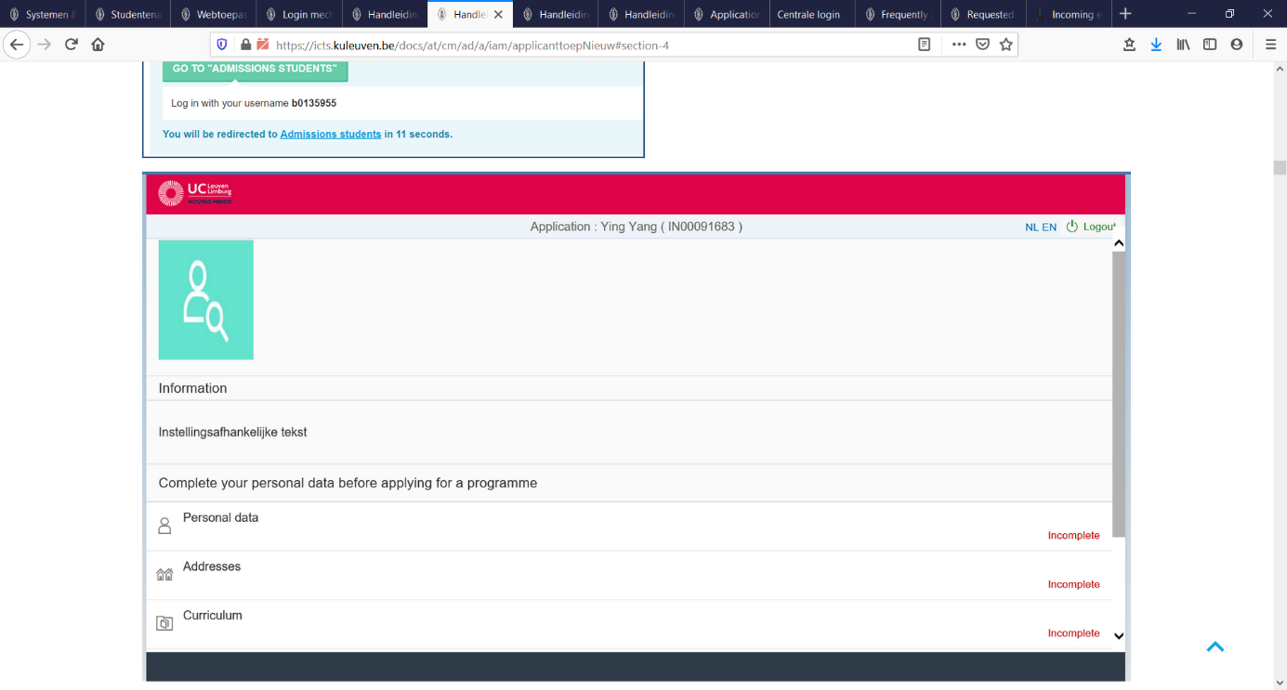

**! Section Curriculum – important !**

**Current or most recent secondary/high school**: This is only for your secondary education. Information about higher education should only be listed in the fields under ‘Higher Education’.

**Higher Education**: Click on the + icon in the upper right to list all of your previous education starting with your highest education.

**! Important!**

If some applicant information (Personal data, Addresses, Curriculum & Languages) is already filled in or cannot be changed, this means your application dossier is already linked to an existing student file in the SAP student registrar’s system of LUCA. Hence, not all applicant information is adjustable anymore!

## **Step 5: Add a new application**

🡪 After filling in the Applicant information, return to the main page ('<' button on top of the page) and use the **‘+’** button in the lower right corner of the page to add a **new application.**

🡪 Type of programme: Choose ‘Exchange’

🡪 Academic year: Choose the year you’ll be studying at LUCA: 2021-2022

🡪 Programme: Choose **one** programme option. These are listed in Dutch, but you can find the English translation in the table below.

**Note:** As of ‘21-22 onwards you can choose **only one** exchange programme! Besides the name of the discipline/programme you will also find the campus and the location where the programme is offered. (A full list of exchange courses per semester can be found [here](https://www.luca-arts.be/sites/default/files/exchange_courses_per_semester_2.pdf))

|  |  |
| --- | --- |
| **Dutch** | **Translation in English** |
| Registratie inkomende uitwisselingen Fotografie (Vorst) | Registration incoming exchange Photography (campus Narafi, Vorst) |
| Registratie inkomende uitwisselingen Film (Vorst) | Registration incoming exchange Film (campus Narafi, Vorst) |
| Registratie inkomende uitwisselingen Audiovisuele kunsten (Brussel) | Registration incoming exchange Audio-visual Arts (campus Sint-Lukas, Brussels):   * Film * Animation film |
| Registratie inkomende uitwisselingen Beeldende kunsten (Brussel) | Registration incoming exchange Visual Arts (campus Sint-Lukas, Brussels):   * Fine Arts * Photography * Media & Information Design * Graphic Storytelling |
| Registratie inkomende uitwisselingen Bouw (Brussel) | Registration incoming exchange Construction Technology (campus Sint-Lukas, Brussels) |
| Registratie inkomende uitwisselingen Interieurvormgeving (Brussel) | Registration incoming exchange Interior Design (campus Sint-Lukas, Brussels) |
| Registratie inkomende uitwisselingen Audiovisuele kunsten (Genk) | Registration incoming exchange Audio-visual Arts (campus C-Mine, Genk):   * Television-Film * Animation film * Game design |
| Registratie inkomende uitwisselingen Beeldende kunsten (Genk) | Registration incoming exchange Visual Arts (campus C-Mine, Genk):   * Photography |
| Registratie inkomende uitwisselingen Productdesign (Genk) | Registration incoming exchange Product Design (campus C-Mine, Genk) |
| Registratie inkomende uitwisselingen Beeldende kunsten (Gent) | Registration incoming exchange Visual Arts (campus Sint-Lucas, Ghent):   * Fine Art (Studios Glass & Ceramics, Painting, Sculpture, Printmaking & Drawing, Photography, Mixed Media, Illustration) * Textile Design * Graphic Design |
| Registratie inkomende uitwisselingen Beeldende vormgeving (Gent) | Registration incoming exchange Visual Design (campus Sint-Lucas, Ghent):   * Graphic Studio * Advertising Studio * Digital Studio * Studio Still |
| Registratie inkomende uitwisselingen Interieurvormgeving (Gent) | Registration incoming exchange Interior Design (campus Sint-Lucas, Ghent) |
| Registratie inkomende uitwisselingen Muziek (Lemmens) | Registration incoming exchange Music (campus Lemmens, Leuven) |
| Registratie inkomende uitwisselingen Drama (Lemmens) | Registration incoming exchange Drama (campus Lemmens, Leuven) |

🡪 Type of exchange: Choose one of the following exchange types

|  |  |
| --- | --- |
| **Exchange type** | **Description** |
| Erasmus study | For students who come from a **European** university and in the framework of the Erasmus+ exchange programme |
| Erasmus Belgica study | For students who come from a **French/German speaking university in Belgium** in the framework of Erasmus Belgica exchange programme |
| E+ Partner countries Study | For students who come from a **non-European** university and in the framework of the Erasmus+ exchange programme |
| Erasmus work placement | For applicants who come from a **European** university and undertake an traineeship/workplacement in the framework of the Erasmus+ exchange programme; either as enrolled student in a home university or as recent graduate |
| Faculty exchange agreement | For students who come from a European or non-European university with whom LUCA signed a bilateral cooperation agreement. Student may be using other scholarship programmes than Erasmus+ (PCP, Asem-Duo, Global Minds, national Grants…) |
| Other | Specifally for PhD- or research related exchange |

🡪 Home University: Name of the sending university in your home country

🡪 Country of home university: Drop-down list. Choose the correct country

🡪 Name contact person home university: the name of a contact person at the sending university

🡪 E-mail contact person home university: the e-mail of the contact person

🡪 Telephone contact person home university: telephone number of the contact person

🡪 Name contact person LUCA: Choose your contact person at LUCA, linked to your campus:

|  |  |
| --- | --- |
| **Campus** | **Contact person** |
| Campus Lemmens, Leuven | Emelie De Bruyne: [emelie.debruyne@luca-arts.be](mailto:emelie.debruyne@luca-arts.be) |
| Campus Sint-Lukas, Brussel | Hannah Dick: [hannah.dick@luca-arts.be](mailto:hannah.dick@luca-arts.be) |
| Campus Sint-Lucas, Ghent | Veerle Van den Abbeele:  [veerle.vandenabbeele@luca-arts.be](mailto:veerle.vandenabbeele@luca-arts.be) |
| Campus Narafi, Vorst | Hannah Dick: [hannah.dick@luca-arts.be](mailto:hannah.dick@luca-arts.be) |
| Campus C-Mine, Genk | Jan Louis De Bruyn: [janlouis.debruyn@luca-arts.be](mailto:janlouis.debruyn@luca-arts.be) |
| Institutional Erasmus coordinator LUCA | Wim Aerts: [wim.aerts@luca-arts.be](mailto:wim.aerts@luca-arts.be) |

🡪 Number years of completed years of study: the number of completed years in your current study programme(=> enrolling in 3BA = 2 completed years)

🡪 Date of arrival / date of departure: the presumed date of arrival and departure

🡪 Field of study: Please fill in the official name of the programme (including specialisation). You can find an overview of all exchange programmes with their official/specific names at: [exchange_courses_per_semester_2.pdf (luca-arts.be)](https://www.luca-arts.be/sites/default/files/exchange_courses_per_semester_2.pdf)

🡪 Where did you hear about our programme: Choose one of the options (drop-down menu)

🡪 Additional remarks: Add additional remarks

**Step 6: Upload attachments supporting your application**

🡪 Use the pencil symbol below to open your application

🡪 Open the Documents section:

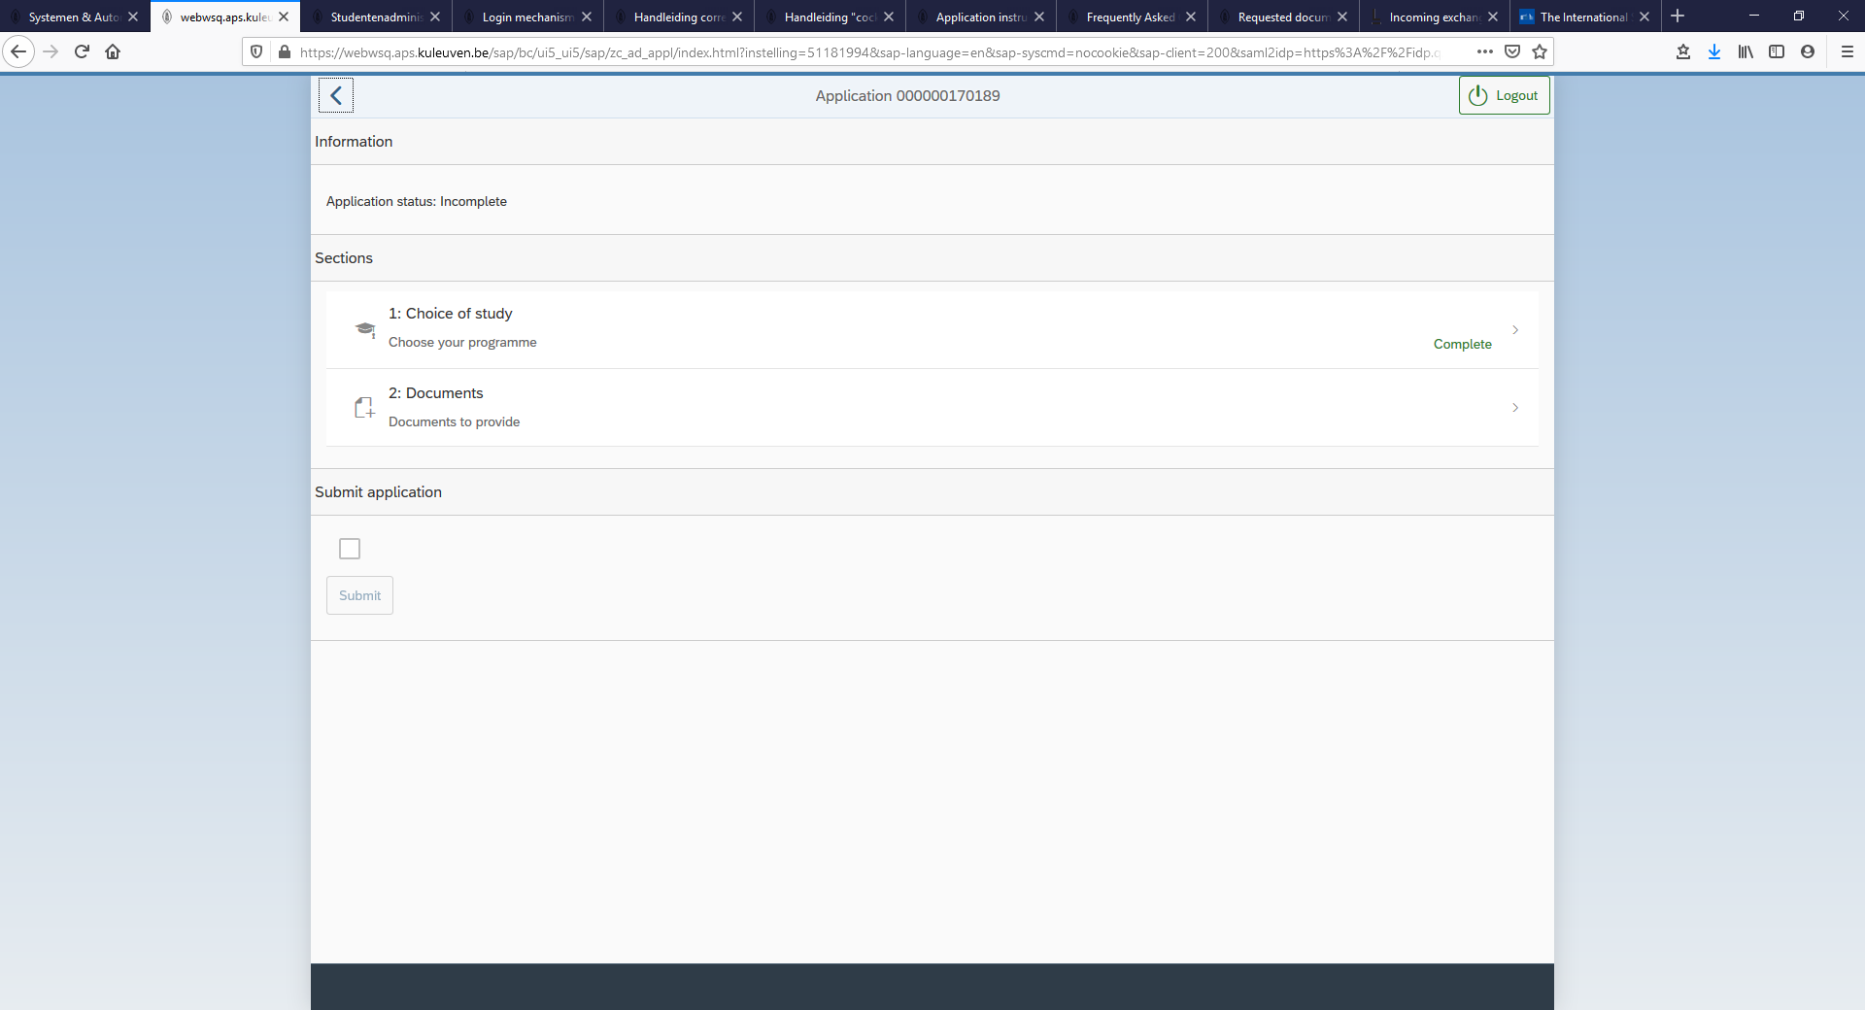

🡪 Upload the documents one-by-one by selecting the attachment and clicking on ‘Upload’. The following documents are required (pdf format):

> **CV** (required)

> **Passport** (EEA citizens can also upload their national ID card instead) (required)

> **Diploma & Transcripts of records** (required): LUCA only needs the transcript of records (which contains the grades/study results you have obtained so far at your home university in the study programme you currently are enrolled for)

> **Motivation letter** (required)

> **Portfolio** (required)

> **Letter of nomination** (required): letter or e-mail from your home International Office by which you are formally nominated as exchange student for LUCA

> **Documents confirming special needs**, if needed (optional)

> Others (if any)

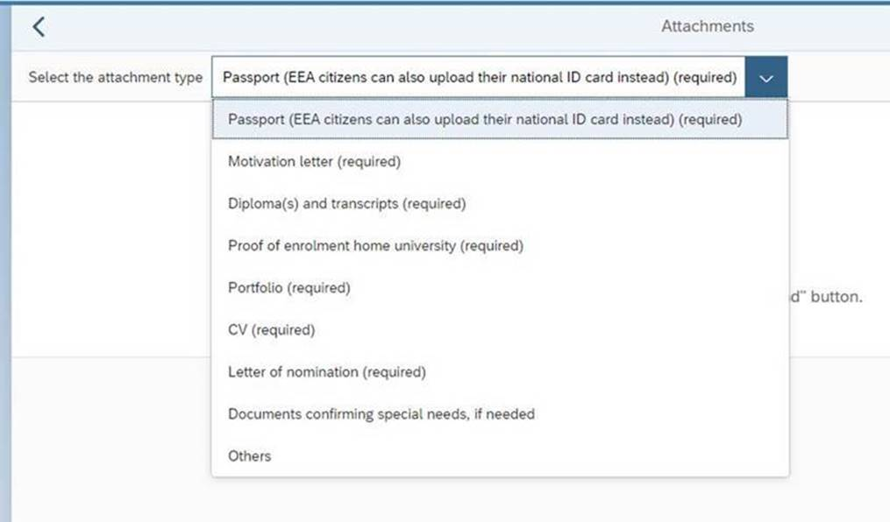

🡪 Mark the ‘submit’ box and submit your documents

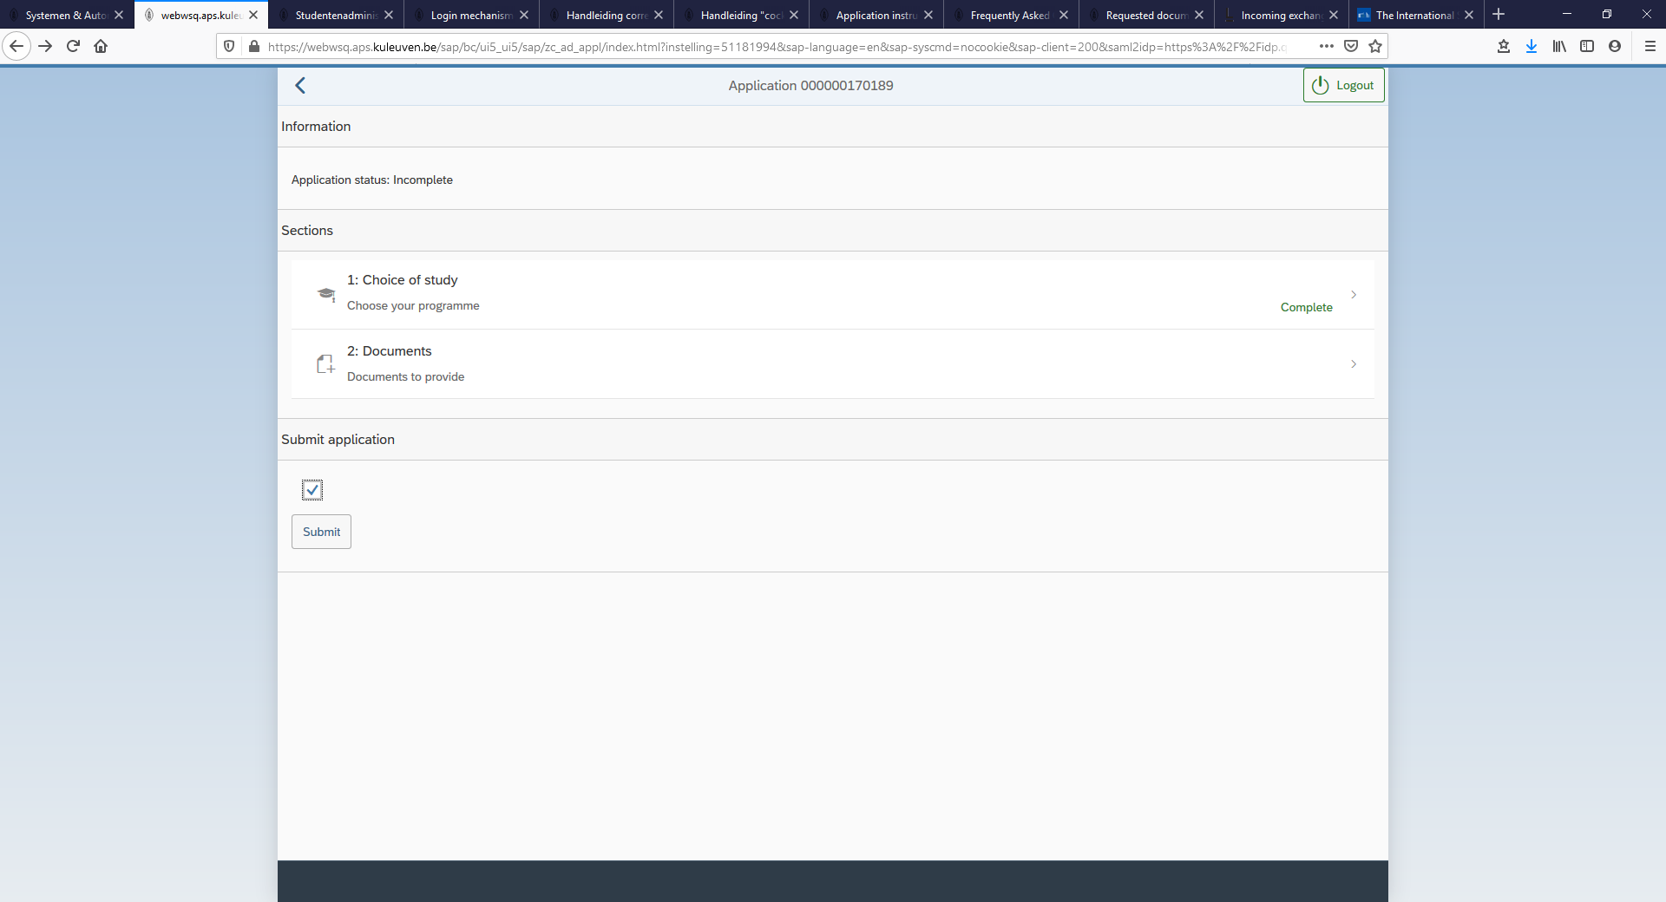

|  |
| --- |
| **Problem solving Upload of Documents!**   1. If you forget to complete your applicant profile or you forget to upload the required documents, the following error message(s) might appear. Make the necessary changes and try to re-submit. 2. Checklist with regards to the upload:  * Are your documents in a PDF format? If not, you will need to convert your files using a special conversion tool likeCutePDFor PrimoPDF. * Is the name you have given to the document too long or does it contain strange characters? Try changing the name of the document and uploading it. * Is the PDF protected? Often electronic pdf copies of transcripts or TOEFL/IELTS score cards are protected and therefore cannot be uploaded as such. You can either take a screenshot and save it as a pdf or print and then scan the document to create a new PDF. * They should not be of a very heavy size- we would advise you to reduce/compress the size of the PDF or upload several documents in the same category instead of a one heavy file. * Sometimes, documents cannot be uploaded in the same category. In that case, you can upload the documents under ‘Other’ category * You could also try using a different browser. |

🡪 Confirm that you want to submit your application

­­­

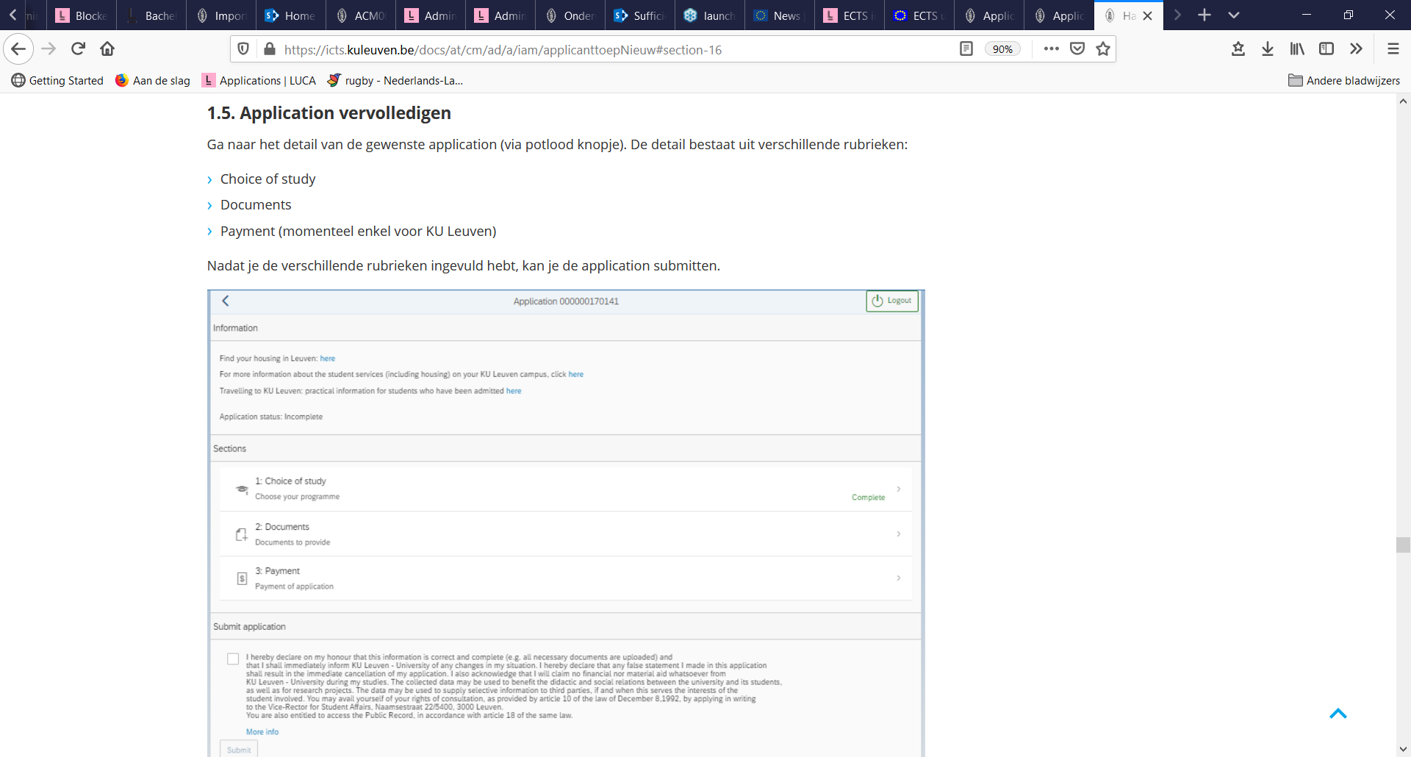

## **Technical problems/support**

If you are experiencing problems while completing your account registration or submitting your application please follow these steps:

1. Always take and save clear screenshots of the problem or the error log(s)
2. Send the information to LUCA International Office at international@luca-arts.be

**Good luck with your application!**